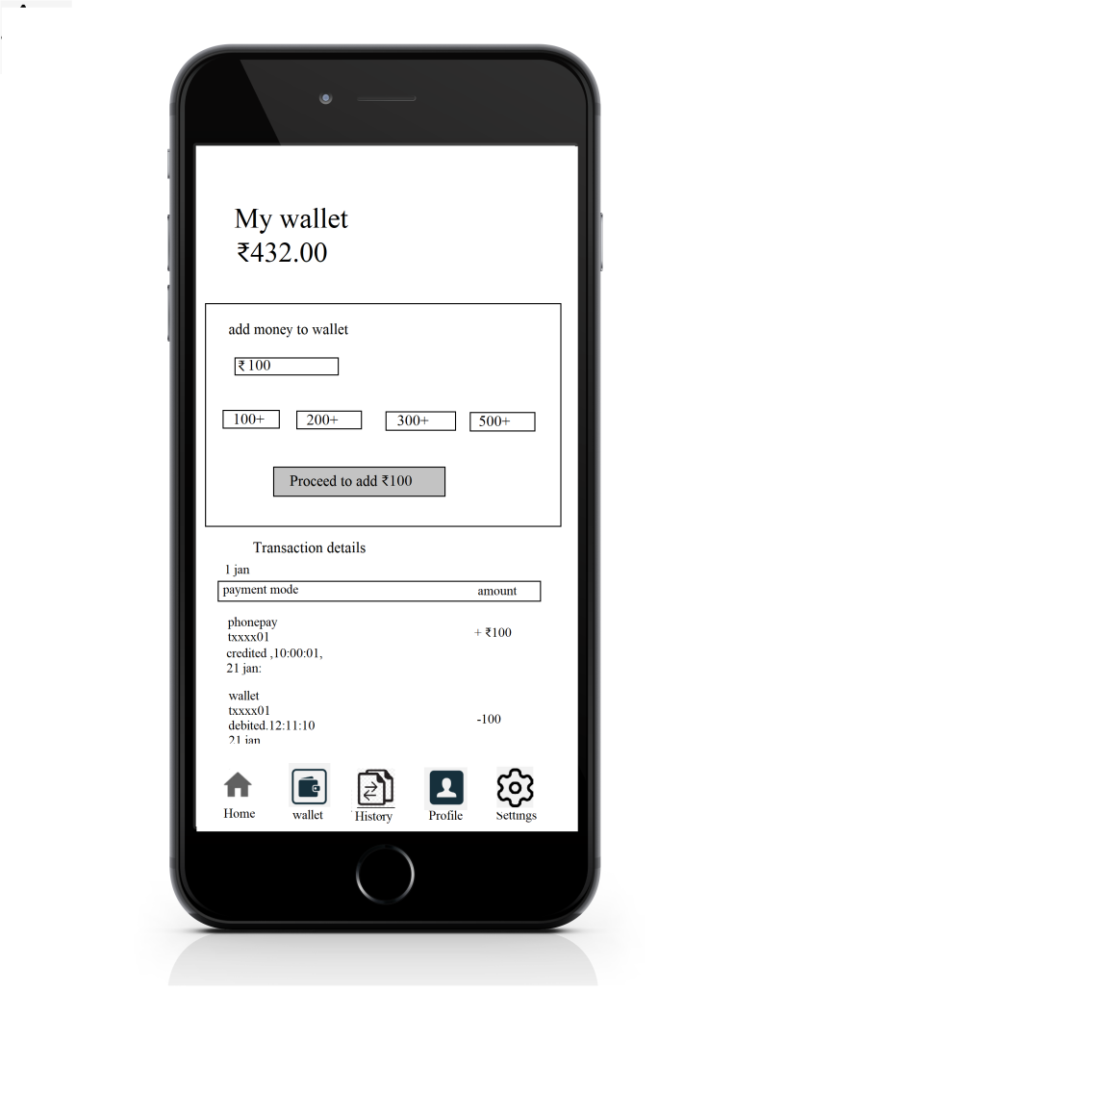

**My wallet**: my wallet is used to buy items ,and we can add the money from some payment modes (phone pay ,gpay, paytm, and etc).

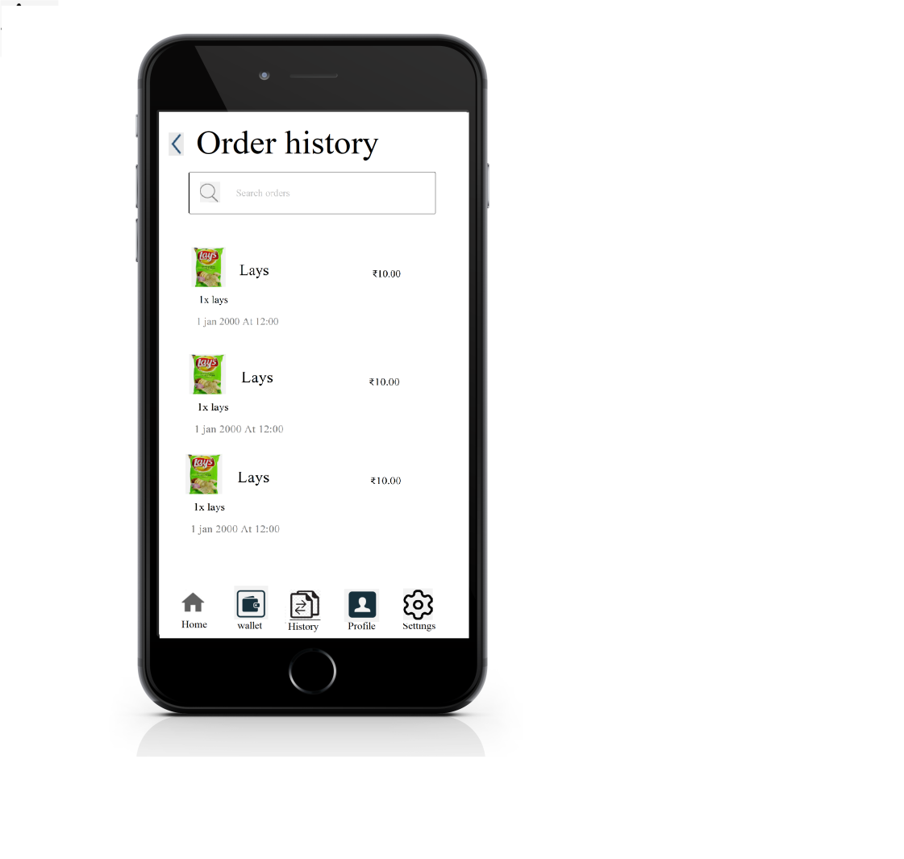

**Order’s History:** We can see our order history, which we have ordered.

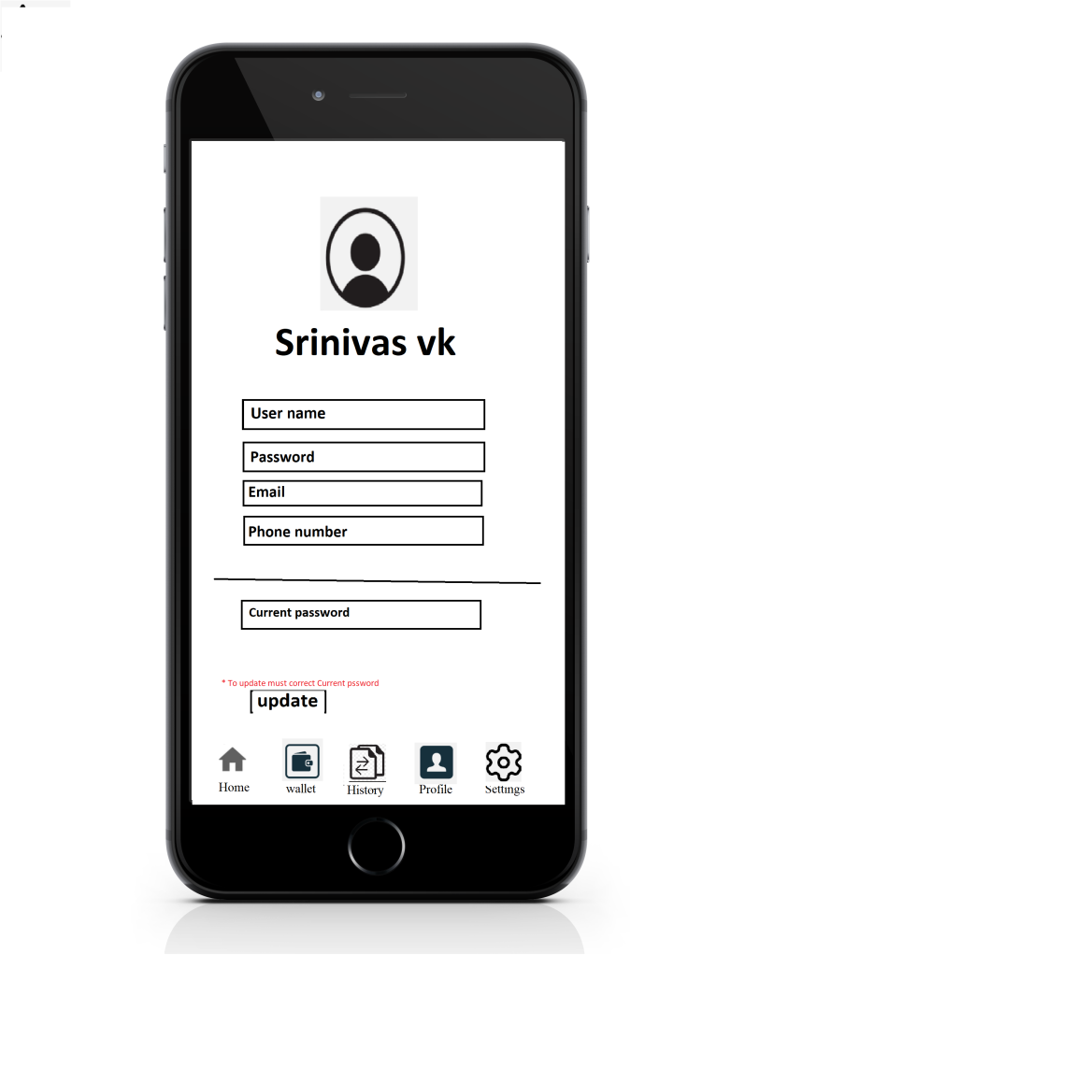

**Profile**: In profile we can change Our user name , password, email, and number,

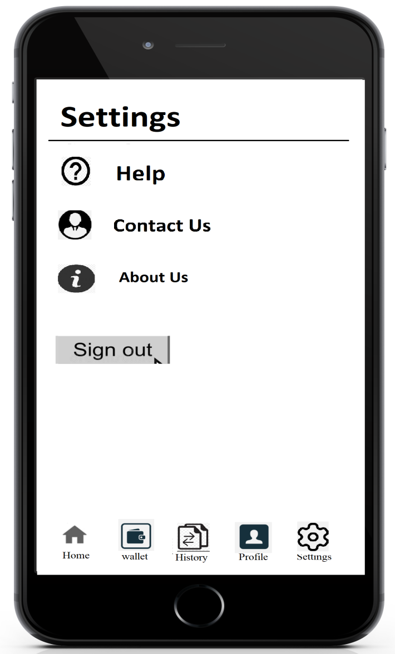

**Settings**: setting to know Addition information

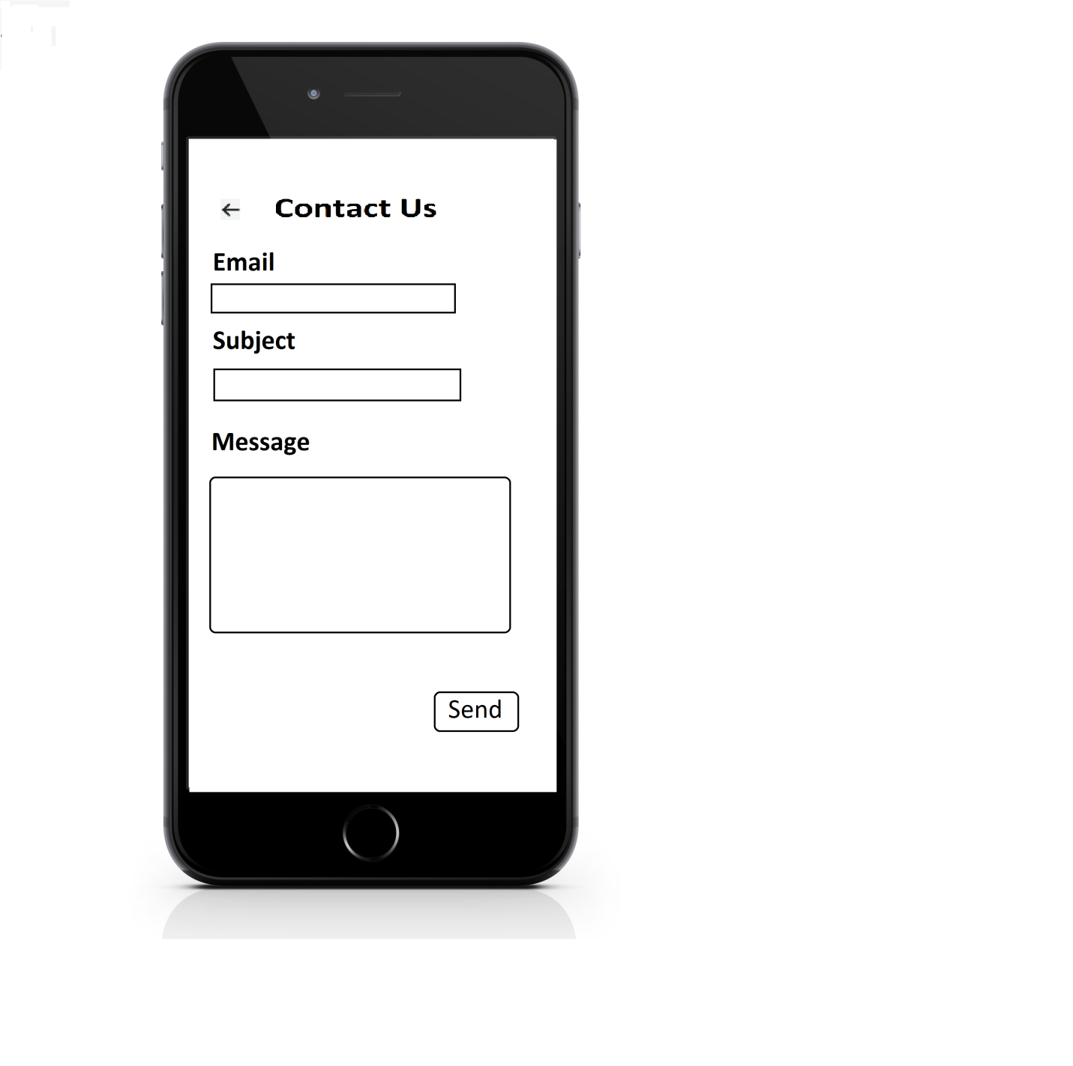

**Contact Us:using contact us form, the customer can contact with there issus.**